SOFTWARE REQUIREMENTS SPECIFICATION

**For**

**Online Quiz System**

# Introduction

## Purpose

## The primary purpose of an online quiz system is to offer a digital platform for the streamlined creation, administration, and evaluation of quizzes, exams, or tests. This system aims to enhance accessibility by allowing users to engage in quizzes from any location with internet connectivity, promoting flexibility for both students and instructors. It automates key processes, including quiz creation, distribution, and grading, thereby saving time and reducing manual efforts for instructors. With scalability as a key feature, the system can accommodate varying numbers of users and quizzes, ensuring adaptability to changing demands. Security measures are implemented to protect quiz content, prevent cheating, and maintain the integrity of assessment results. The system also supports different user roles, providing appropriate permissions for creating, taking, and managing quizzes. Through features like timely feedback, efficient data management, and detailed reporting, the online quiz system enhances the overall assessment experience in educational and training environments.

## **1.2 Document Conventions**

* + - Entire document should be justified.
    - Convention for Main title

Font face: Times New Roman Font style: Bold

Font Size: 14

* + - Convention for Sub title

Font face: Times New Roman Font style: Bold

Font Size: 12

* + - Convention for body

Font face: Times New Roman Font Size: 12

## 1.3 Scope of Development Project

The scope of developing an online quiz system project encompasses several key aspects to ensure a comprehensive and effective solution. Firstly, the project should involve the creation of an intuitive and user-friendly interface that allows instructors to easily author various types of quizzes, including multiple-choice, true/false, and open-ended questions. The system should support customization options such as time limits, question randomization, and difficulty levels.

User management is a crucial component, necessitating the implementation of roles and permissions for administrators, instructors, and students. This involves overseeing user registration, authentication, and authorization processes, ensuring a secure and controlled environment.

The project scope should include features that enhance the overall user experience for students, such as clear navigation, accessibility across devices, and immediate feedback on quiz performance. Additionally, incorporating measures to prevent cheating, secure quiz content, and maintain result integrity is paramount.

Scalability is a critical consideration, allowing the system to accommodate a growing user base and increasing quiz loads. The development project should also address performance requirements, ensuring the system operates efficiently, with minimal downtime and quick response times.

Furthermore, the online quiz system should generate comprehensive reports for instructors and administrators. These reports should offer insights into overall performance metrics, individual student achievements, and areas requiring improvement.

In summary, the scope of developing an online quiz system project involves creating a robust, scalable, and user-friendly platform that addresses quiz creation, user management, security, scalability, performance, and reporting features to meet the needs of educational and training environments.

## 1.4 Definitions, Acronyms and Abbreviations

1. Quiz:

Definition: A set of questions or exercises designed for assessment or testing purposes.

2. MCQ:

Acronym: Multiple Choice Questions

Definition: Questions where respondents choose from a set of predefined options.

3. T/F:

Abbreviation: True/False

Definition: A question format requiring respondents to determine the correctness of a given statement.

4. User Roles:

Definition: Different levels of access and permissions assigned to users, such as Administrator, Instructor, and Student.

5. Authentication:

Definition: The process of verifying the identity of a user, ensuring that only authorized individual

access the system.

6. Scalability:

Definition: The system's ability to handle a growing number of users, quizzes, or transactions effectively.

7. Feedback:

Definition: Information provided to users regarding their performance in a quiz, often immediate and constructive.

8. Security Token:

Definition: A piece of data used for user authentication, enhancing the security of the login process.

9. API:

Acronym: Application Programming Interface

Definition: A set of rules that allows one software application to interact with another.

10. Dashboard:

Definition: A visual interface providing an overview of relevant information, such as quiz statistics or user performance.

11. Randomization:

Definition: The process of arranging questions or answer options in a random order to

prevent predictability.

12. Performance Metrics:

Definition: Quantifiable measures assessing the efficiency and responsiveness of the online quiz system.

## 1.5 References

* + - Academic Journals

 Smith, J., & Johnson, A. (Year). "Assessing the Effectiveness of Online Quiz Systems in Higher Education." Journal of Educational Technology, 20(3), 123-145.

* + - Books:

Brown, C., & Miller, D. (Year). Designing Interactive Quizzes for E-Learning: A Practical Guide Publisher.

* + - Conference Papers:

Anderson, M., & White, B. "Innovations in Online Assessment: A Case Study of an Adaptive Quiz System." In *Proceedings of the International Conference on E-Learning (pp. 45-56).

* + - Educational Technology Magazines:

Educational Technology Today."Innovations in Assessment: The Role of Online Quizzing." Educational Tech Today, 15(4), 34-39.

# Overall Descriptions

## Product Perspective

Use Case Diagram of Online Quiz System

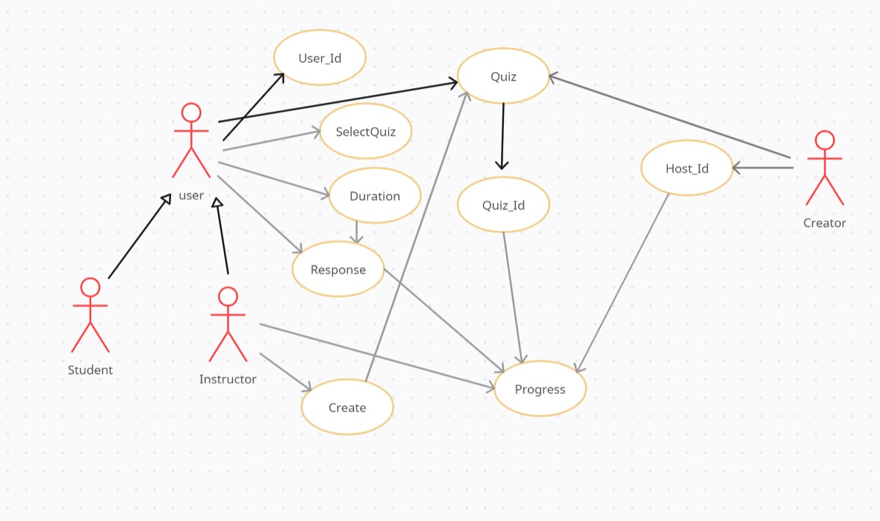

A case diagram for an online quiz system visually represents the interactions between various actors and the system itself. The primary actors typically include "Administrator" and "User," with the system identified as the boundary. The "Administrator" has the ability to create, modify, and manage quizzes, while the "User" is involved in activities such as taking quizzes, receiving feedback, and accessing results. The system's functionalities, represented as use cases, encapsulate actions like "Create Quiz," "Take Quiz," "View Results," and "Provide Feedback." These use cases demonstrate the core features offered by the system. Relationships between actors and use cases are illustrated by association lines, showing which actors are involved in specific interactions. For instance, the "Administrator" is associated with use cases related to quiz creation, while the "User" is linked to activities related to quiz participation. The case diagram provides a high-level overview of the system's functionality and the roles of different actors within the online quiz ecosystem.

## Product Function

Entity Relationship Diagram of Online Quiz System

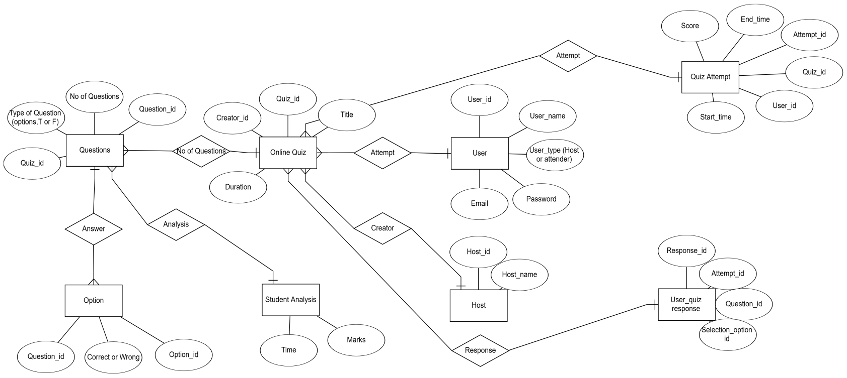

The Entity-Relationship (ER) diagram for the online quiz system visually represents the relationships between key entities and their attributes. In this context, essential entities include "User," "Quiz," "Question," and "Category." The "User" entity captures information such as user ID, username, and authentication details. The "Quiz" entity encompasses attributes like quiz ID, duration, and results. Each quiz is associated with multiple "Questions," which have attributes like question ID, content, and correct answers. The "Category" entity helps in organizing questions by topics or difficulty levels. Relationships are established between these entities to illustrate how they interact. For example, a user can take multiple quizzes, linking the "User" and "Quiz" entities in a one-to-many relationship. Similarly, a "Quiz" can have multiple "Questions," forming another one-to-many relationship. The "Category" entity is linked to the "Question" entity in a many-to-many relationship, indicating that a question can belong to multiple categories, and a category can include multiple questions. Overall, the ER diagram provides a comprehensive overview of the data model, aiding in the design and understanding of the online quiz system's database structure..

## User Classes and Characteristics

In the development of an online quiz system, various user classes contribute to a well-rounded and functional platform. These user classes typically include administrators, instructors, and students, each with unique characteristics and responsibilities:

1. Administrators:

Role: Administrators have the highest level of authority in the system, overseeing its

overall functioning.

Characteristics:

- Manage user accounts, including creation, modification, and deletion.

- Configure system-wide settings and parameters.

- Ensure system security and implement access controls.

- Monitor and generate reports on system analytics and usage.

- Handle global aspects of content management and compliance.

2. Instructors:

Role: Instructors play a pivotal role in creating and managing quizzes, as well as overseeing

student performance.

Characteristics:

- Create and customize quizzes, selecting question formats and setting parameters.

- Manage course materials, including content uploads and organization.

- Evaluate and grade quizzes, providing feedback to students.

- Communicate with students through announcements and messages.

- Monitor and analyze student performance through detailed reports.

3. Students:

Role: Students are the end-users who engage with the online quiz system to participate in quizzes and access learning materials.

Characteristics:

- Access and participate in quizzes within specified time limits.

- View and download course materials, lecture notes, and resources.

- Track personal progress, including quiz scores and overall performance.

- Engage in communication with instructors and peers.

- Manage their profiles, update personal information, and access learning history.

Balancing the distinct characteristics of these user classes is essential for creating an online quiz system that caters to the varied needs and responsibilities of administrators, instructors, and students. This ensures a comprehensive and user-friendly platform that supports effective teaching, learning, and system administration.

## Operating Environment

## The operating environment for an online quiz system encompasses the technological and infrastructure requirements essential for its seamless functionality. The system is designed to operate within a web-based environment, requiring compatibility with standard web browsers such as Chrome, Firefox, and Safari. It should be adaptable to various operating systems, including Windows, macOS, and Linux, to ensure accessibility for a diverse user base. The online quiz system relies on a robust internet connection to facilitate user interactions, quiz submissions, and data retrieval. Additionally, server-side components must be scalable and well-maintained to handle concurrent user activities and ensure optimal performance. Integration with database systems is crucial for secure storage and retrieval of user accounts, quiz content, and performance data. Overall, the online quiz system's operating environment should be versatile, reliable, and conducive to a smooth user experience across different devices and network conditions.

## Assumptions and Dependencies

## **Assumptions:**

## 1. Internet Connectivity: The assumption that users, both instructors, and students, have reliable and consistent internet connectivity to access the online quiz system.

## 2.Device Compatibility: Assuming that users have access to devices (computers, tablets, or smartphones) that are compatible with the system's web-based interface.

## 3. Browser Compatibility: Assuming that users utilize modern web browsers (Chrome, Firefox, Safari, etc.) that are compatible with the online quiz system.

## 4. User Proficiency: Assuming a basic level of computer literacy among users, allowing them to navigate and interact with the online quiz system effectively.

## 5. Data Accuracy: Assuming that the data input by administrators, instructors, and students is accurate and reliable for proper functioning of the system.

## 6. Secure Environment: Assuming that security measures, such as firewalls and encryption protocols, are in place to protect user data and prevent unauthorized access.

## **Dependencies:**

## 1. Database System: The online quiz system depends on a reliable and well-maintained database system to store user accounts, quiz content, and performance data securely.

## 2. Web Hosting Services: Dependencies on web hosting services to ensure the system is accessible to users over the internet with minimal downtime.

## 3. Third-Party Libraries/Frameworks: Dependencies on specific programming libraries or frameworks that the system may use for functionalities such as authentication, data processing, or user interface components.

## 4. Browser Features: Dependencies on features and capabilities provided by web browsers to support the interactive and dynamic elements of the online quiz system.

## 5. Regular Maintenance: The system depends on regular maintenance activities to address any bugs, security vulnerabilities, or performance issues that may arise during its operation.

## Identifying and documenting these assumptions and dependencies is crucial during the planning and development stages of the online quiz system to ensure a realistic understanding of the environment in which the system will operate. It also helps in managing expectations and planning for contingencies in case certain assumptions are not met or dependencies are disrupted.

## Requirement

Software Requirements:

1. Operating System: Compatible with Windows, macOS, and Linux.

2. Web Browser: Supports major browsers like Chrome, Firefox, Safari, and Edge.

3. Server-Side Technology: Utilizes server-side technologies such as Node.js, Django,

or Ruby on Rails.

4.Database: Requires a relational database management system (RDBMS) like

MySQL or PostgreSQL.

1. Development Framework: Built using a web development framework such as React,

Angular, or Vue.js.

1. Security Software: Implements security protocols like HTTPS and may

integrate with authentication services.

Hardware Requirements:

1. Server: Requires a robust web server to host the online quiz system, with adequate

processing power and memory.

2. Network Infrastructure: Relies on a stable internet connection and sufficient

bandwidth for seamless user interactions.

3. Client Devices: Compatible with various devices including laptops, desktops,

tablets, and smartphones.

4. Storage: Sufficient storage capacity for the database and media files associated with quizzes.

5. Memory (RAM): Adequate RAM to support concurrent user activities and system responsiveness.

These requirements ensure the effective operation of the online quiz system,

providing flexibility for users while maintaining security and performance standards.

## Data Requirement

The data requirements for an online quiz system encompass both input and output elements essential for seamless functionality. Input data includes user-generated information during the quiz creation and participation processes. This comprises quiz questions, answer choices, time limits, and instructor-specific settings. Additionally, user authentication data, such as usernames and passwords, serves as crucial input for securing user accounts. On the output side, the system generates various data sets. For administrators and instructors, output data includes analytics and reports detailing user activity, quiz performance, and system usage statistics. For students, the system produces real-time feedback on quiz responses, final scores, and progress metrics. Audit trails and logging data serve as essential outputs for system administrators to monitor and troubleshoot. Collectively, these input and output data elements facilitate a dynamic and user-centric online quiz experience while providing valuable insights for assessment and system management.

# External Interface Requirement

## GUI

The Graphical User Interface (GUI) requirements for an online quiz system play a pivotal role in user interaction and experience.

1.The system's interface should be intuitive and user-friendly,

featuring clear navigation menus and logically organized elements.

2.A dashboard should provide at-a-glance information, including

upcoming quizzes, recent scores, and course progress.

3.The quiz creation interface for instructors should offer an easy-to-use

platform to generate diverse question formats, set time limits, and configure

quiz parameters. Students, on the other hand, should experience a streamlined

and responsive interface for quiz participation, with clear instructions and

progress indicators.

4.Consistent design elements, such as color schemes and fonts, should

enhance visual appeal and maintain a cohesive user experience.

5.The GUI should be accessible on various devices, ensuring responsiveness

and usability across laptops, tablets, and smartphones.

6.Additionally, incorporating features like multimedia support, interactive

question types, and immediate feedback enhances user engagement.

7.By prioritizing a well-designed and user-centric GUI, the online quiz system

can optimize the learning and assessment experience for both instructors

and students.

External interface requirements

1. User Interface (UI):

Requirement: The system should provide a user-friendly web interface accessible across major browsers (Chrome, Firefox, Safari) and devices (laptops, tablets, smartphones).

2. Authentication Services:

Requirement: Integration with external authentication services (e.g., OAuth, LDAP) to ensure secure and efficient user login.

3. Payment Gateway:

Requirement: If applicable, integration with a secure payment gateway to facilitate financial transactions for premium features or paid access.

4. Learning Management Systems (LMS) Integration:

Requirement: Compatibility with LMS platforms for seamless integration into broader educational frameworks.

5. Content Management Systems (CMS) Integration:

Requirement: Compatibility with external CMS for efficient management and incorporation of multimedia content within quizzes.

6. APIs for Analytics:

Requirement: Implementation of APIs to integrate with analytics tools or services, providing administrators and instructors with detailed reports and performance metrics.

7. Communication Services Integration:

Requirement: Integration with external communication services (e.g., email, messaging) for notifications, announcements, and effective communication between instructors and students.

8. Accessibility Standards:

Requirement: Adherence to external accessibility standards (e.g., WCAG) to ensure inclusivity and accessibility for users with diverse needs.

9. Browser Compatibility:

Requirement: Ensuring compatibility with various web browsers and their different versions to deliver a consistent experience for users.

10. Security Protocols:

Requirement: Compliance with external security protocols and standards to safeguard user data and maintain the integrity of assessments.

11. Scalability Considerations:

Requirement: Consideration of external cloud services or server infrastructure that supports scalability during periods of increased user demand.

12. Mobile Application Interface (if applicable):

-Requirement: If a mobile application is developed, ensuring compatibility with major mobile operating systems (iOS, Android) and providing a seamless interface for quiz participation on mobile devices.

These external interface requirements are vital for ensuring the online quiz system's effective integration with external components and services, enhancing its functionality and usability within diverse educational environments.

# System Features

For Students:

- Intuitive interface for easy quiz participation.

- Immediate feedback and access to learning materials.

For Instructors:

- Quiz creation and customization tools.

- Efficient grading, feedback, and real-time monitoring.

For Administrators:

- Global system configuration and security management.

- Comprehensive analytics and scalability tools.

# Other Non-functional Requirements

## Performance Requirement

An effective online quiz system must meet stringent performance requirements to ensure a seamless user experience.

1.It should exhibit low latency, enabling swift response times when users submit answers or navigate through questions.

2.Scalability is crucial to accommodate varying user loads, ensuring consistent performance during peak usage periods.

3.The system should also be resilient, capable of handling potential server failures or unexpected disruptions without compromising user data or interrupting ongoing quizzes.

4.Additionally, efficient database management is vital to support quick retrieval and storage of quiz-related information.

5.To enhance user engagement, the system should provide real-time feedback and updates.

Overall, a robust online quiz system must prioritize speed, scalability, reliability, and responsiveness

to meet the demands of a diverse and dynamic user base.

## Safety Requirement

Ensuring the safety and security of users and their data is paramount for an online quiz system. The system must implement stringent measures to safeguard personal information, preventing unauthorized access, data breaches, or malicious activities. Secure user authentication mechanisms, such as robust password policies and multi-factor authentication, should be in place to verify the identity of participants. The platform should encrypt data transmission to protect sensitive information during communication between users and the server. Additionally, the system must incorporate secure coding practices to mitigate vulnerabilities and resist common cyber threats such as SQL injection or cross-site scripting. Regular security audits, updates, and patches are essential to address emerging risks and vulnerabilities. Privacy concerns should be addressed by transparently communicating data handling practices and obtaining user consent for information processing. Overall, a comprehensive safety strategy should be integrated into the online quiz system to instill confidence in users regarding the confidentiality and integrity of their data.

## Security Requirements

* + - Implement strong authentication and authorization.
    - Use encryption for secure data transmission.
    - Follow secure coding practices to prevent vulnerabilities.
    - Regularly audit and update security measures.
    - Apply role-based access controls for user privileges.
    - Utilize firewalls to filter and monitor network traffic.
    - Employ secure session management practices.
    - Regularly back up quiz data to prevent loss.
    - Adhere to privacy regulations and obtain user consent.
    - Develop and implement an incident response plan.
    - Ensure secure integrations with third-party services.
    - Establish monitoring and logging for user activities.

## Requirement attributes

* + - There may be multiple administrators creating the quiz, all of them will have the right to create changes to the application. But students cannot do changes.
    - ➢The project should be open source.
    - ➢The Quality of the database is maintained in such a way so that it can be very user friendly to all the students of the database

## Business Rules

The online quiz system adheres to several key business rules to ensure its effective operation and alignment with organizational objectives. Firstly, exclusive rights for system modifications are granted to designated administrators, maintaining the system's integrity and security. Allowing multiple administrators the ability to create changes facilitates collaborative management and swift updates. Secondly, as an open-source project, the system encourages community involvement, fostering collaboration among developers, educators, and users for continuous improvement.

Thirdly, the database, a critical component of the system, is designed with user-friendly structures

and optimized queries to enhance the overall quality of user interaction. The ease of download

and installation further promotes accessibility for users with varying technical expertise.

A scalable user management system accommodates the potential growth of administrators

and users, ensuring smooth handling of accounts and permissions. Additionally, stringent

quality assurance practices are implemented to maintain the system's reliability and

functionality. Comprehensive documentation and support mechanisms are in place to

assist administrators and users, emphasizing a user-centric approach. Lastly, the system adheres

to accessibility standards, promoting inclusivity, while feedback mechanisms provide a channel

for continuous improvement based on user insights. These business rules collectively contribute to

the robustness, flexibility, and user-friendliness of the online quiz system.

## User Requirement

User requirements for an online quiz system are crucial to ensure that the system meets the needs and expectations of its intended users. The administrators of the system should have more knowledge of the internals of the system and is able to rectify the small problems that may arise due to disk crashes, power failures and other catastrophes to maintain the system. The proper user interface, user manual, online help and the guide to install and maintain the system must be sufficient to educate the users on how to use the system without any problems.

The admin provides certain facilities to the users in the form of:-

* + - Ensure an intuitive and easy-to-navigate interface for users.
    - Allow users to create and customize quizzes with various question types and settings.
    - Provide immediate feedback and detailed analytics for performance assessment.
    - Implement robust security features to protect user data and ensure privacy.
    - Design the system to be accessible to all users and compatible with various devices, including mobile.
    - Notify users about upcoming quizzes, deadlines, and system updates.
    - Offer user support and comprehensive documentation for a positive user experience.
    - Include a feedback mechanism for users to contribute insights for system improvement.

# Other Requirements

## Data and Category Requirement

The online quiz system necessitates robust data management and categorization to effectively organize and deliver quizzes. Data requirements encompass user profiles, ensuring secure storage of personal information and quiz results. Additionally, comprehensive question banks with categories and metadata are vital for varied assessments. The system should facilitate the creation, modification, and deletion of questions, with categorization based on topics, difficulty levels, or other relevant criteria. Efficient storage and retrieval mechanisms must be implemented to support quick access to quiz data, ensuring seamless user experience. Accurate categorization aids administrators in crafting quizzes tailored to specific subjects or skill levels. The system's database should prioritize scalability to accommodate a growing repository of questions and user data while maintaining data integrity and security through encryption and access controls. Effective data and category management form the foundation for a flexible, user-friendly, and adaptive online quiz system.

## Appendix

A: Admin, Abbreviation, Acronym, Assumptions; B: Books, Business rules; C: Class, Client, Conventions; D: Data requirement, Dependencies; F: Feedback; G: GUI; K: Key; I:Instructor; N: Non-functional Requirement; O: Operating environment; P: Performance,Perspective,Purpose; R: Requirement, Requirement attributes; S: Sample quiz templates , Safety, Scope, Security, System features; U: User, User class and characteristics, User requirement;

## Glossary

The following are the list of conventions and acronyms used in this document and the project as well:

* + - Administrator:

A user with elevated privileges responsible for creating, managing, and modifying quizzes within the system.

* + - Authentication:

The process of verifying the identity of a user, typically through a username and password, to grant access to the system.

* + - Category:

A classification or grouping mechanism used to organize questions in the question bank

based on topics, difficulty levels, or other criteria.

* + - Database Schema:

The structure that defines the organization of data in the database, including

tables, relationships, and key attribute

* + - Feedback Mechanism:

A feature allowing users to provide comments, suggestions, or report issues related

to the system.

* + - Open Source:

Refers to the system's availability for public use, modification, and collaboration, allowing

the community to contribute to its development.

* + - Quiz Template:

A pre-defined format or structure that users can utilize to create quizzes, including setting

for question types, time limits, and scoring mechanisms.

* + - Scalability:

The system's ability to handle a growing number of users, questions, and data

without compromising performance.

* + - Security Policies:

Rules and measures implemented to safeguard user data, prevent unauthorized access,

and protect against potential security threats.

* + - System Requirements:

The hardware, software, and network specifications necessary for users to install and run

the online quiz system.

* + - User Authentication:

The process of verifying and confirming the identity of a user to grant access to the

system's features and functionalities

* + - Layer: Represents a section of the project
    - User Interface Layer: The section of the assignment referring to what the user interacts with directly
    - Application Logic Layer: The section of the assignment referring to the Web Server. This is where all computations are completed
    - Data Storage Layer: The section of the assignment referring to where all data is recorded
    - Use Case: A broad level diagram of the project showing a basic overview
    - Class diagram: It is a type of static structure diagram that describes the structure of a system by showing the system’s cases, their attributes, and the relationships between the classes
    - Interface: Something used to communicate across different mediums
    - Unique Key: Used to differentiate entries in a database.

## Class Diagram

A class is an abstract, user-defined description of a type of data. It identifies the attributes of the data and the operations that can be performed on instances (i.e. objects) of the data. A class of data has a name, a set of attributes that describes its characteristics, and a set of operations that can be performed on the objects of that class. The classes’ structure and their relationships to each other frozen in time represent the static model. In this project there are certain main classes

which are related to other classes required for their working. There are different kinds of relationships between the classes as shown in the diagram like normal association, aggregation, and generalization. The relationships are depicted using a role name and multiplicities. Here ‘Librarian’, ‘Member’ and ‘Books’ are the most important classes which are related to other classes.

